18.72: a) 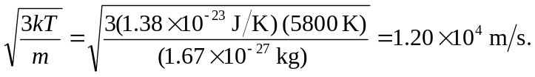

b)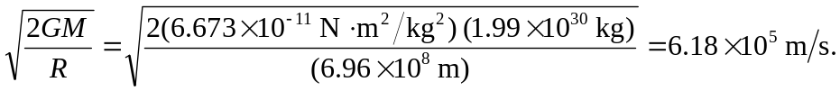

c) The escape speed is about 50 times the rms speed, and any of Fig. 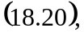 Eq. 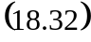 or Table 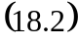 will indicate that there is a negligibly small fraction of molecules with the escape speed.

